Objective
This SOP provides step-by-step instructions for the inspection of PMA articles to ensure compliance with FAA Part 21 regulations. This process ensures standardized inspections, regulatory adherence, and proper documentation prior to release to inventory or shipment. Burrana does not produce Critical Safety Components; all articles fall into low-risk categories.

Applicability
This SOP applies to all Burrana locations and personnel responsible for PMA inspections, including Receiving Inspectors, PMA Inspectors, and Quality Auditors. It covers incoming inspections, in-process inspections, prototype evaluations, final inspections, and the issuance of conformity documentation, including FAA Form 8130-3 and Certificates of Conformance (CoC).

Responsibilities
- FAA Accountable Manager – Provides final approval for this SOP in compliance with FAA requirements.
- Receiving Inspector – Performs initial inspection upon receipt, ensuring articles are correctly identified and directed to the appropriate inspection process.
- PMA Inspector – Conducts inspections, verifies paperwork, performs testing, and determines if an FAA Form 8130-3 or CoC is required.
- Quality Auditors – Conducts audits to verify that inspections align with FAA Part 21 requirements and Burrana’s quality management system.
- Project Engineer – Reviews and approves prototype articles before release to inventory.

Definitions
8130-3ST Form – | A supplemental certificate issued when an 8130-3 is split for partial shipments. The 8130-3ST form accompanies the original 8130-3 to maintain traceability of the split shipment and ensure compliance with FAA documentation requirements.
PMA (Parts Manufacturer Approval) – | FAA approval for manufacturing and selling replacement aircraft parts.
FAIR (First Article Inspection Report) – | A structured process per AS9102 to verify that a new part meets design and quality requirements.
8130-3 Form – | An FAA-issued document certifying an article’s airworthiness.
CoC (Certificate of Conformance) – | A document stating compliance with specified standards when 8130-3 is not applicable.
NCR (Non-Conformance Report) – | Documentation of nonconforming articles requiring disposition.

Process
The process for Inspection takes several steps. Burrana inspectors may be part of the First Article, Incoming Receiving, In-Process, Final, or PMA Inspection processes. Following the process flow, the steps identified in this SOP are used to complete the Inspections.
Incoming Receiving Inspection Process Steps
This section details the step-by-step process for verifying incoming materials, ensuring compliance with regulatory, supplier, and Burrana quality requirements.
The process includes document review, physical inspection, verification of regulatory certifications, handling of bulk and non-bulk shipments, and proper recording of inspection results.
It ensures that all received materials meet required specifications before release to stock or production.
Epicor and QwizPro are used to track the movement of materials, record documentation, and ensure traceability, however, the full inspection process also involves physical verification and coordination with Quality and Engineering when necessary.
- Identify Receiving Location  - When a shipment arrives, determine the Burrana site where it is being received:  - MXL: Standard receiving inspections only. If bulk PMA inspection is required, the shipment must be transferred to Springville, Calexico, or conducted through remote inspection.  - Springville, UT: FAA Part 21-approved facility for PMA inspections, with full authority to issue 8130-3.  - Calexico (CLX): Satellite of Springville with authority to inspect and sign 8130-3.  - If the shipment arrives at a location not authorized for 8130-3 issuance, determine the next step:  - If an 8130-3 is not required, follow the Certificate of Conformance (CoC) process.  - If remote inspection is an option, follow the Virtual Inspection (VI) process.  - If necessary, transfer the shipment to an approved location (Springville or Calexico) for 8130-3 issuance.  - Once the receiving location and required process are determined, proceed to document verification.**  - Determine the Burrana site where the shipment is being received:  - MXL: Standard receiving inspections only. If bulk PMA inspection is needed, the shipment must be transferred to Springville, Calexico, or conducted through remote inspection.  - Springville, UT: FAA Part 21-approved facility for PMA inspections, with full authority to issue 8130-3.  - Calexico (CLX): Satellite of Springville with authority to inspect and sign 8130-3.  - If the shipment arrives at a location not authorized for 8130-3 issuance, it must either:  - Follow the Certificate of Conformance (CoC) process if an 8130-3 is not required.  - Be processed through the Virtual Inspection (VI) process for remote evaluation, if applicable.  - Be transferred to an approved location (Springville or Calexico) if an 8130-3 is necessary. | 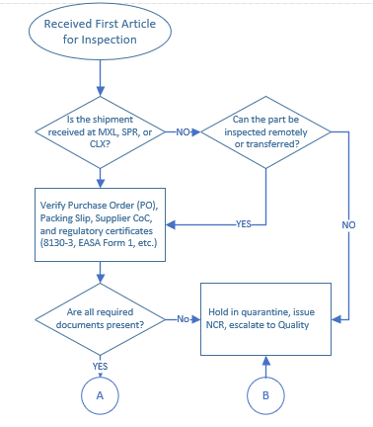  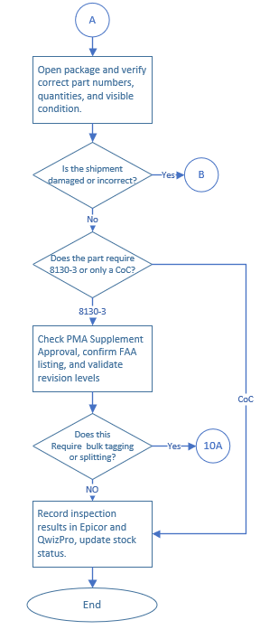
- Receive Shipment & Review Documentation
- Verify shipping paperwork, including:
  - Purchase Order (PO)
  - Packing Slip
  - Supplier Certificate of Conformance (CoC)
  - Any regulatory certificates (FAA 8130-3, EASA Form 1, etc.)
- Attach required documentation to the part record in Epicor.
- MXL is the main manufacturing facility where standard receiving inspections occur. If bulk PMA inspection is needed, the shipment must be sent to Springville, Calexico, or handled through remote inspection.
- Springville, UT is the FAA Part 21 approved facility for PMA inspections and has full authority to issue 8130-3.
- Calexico (CLX) is a satellite location of Springville with authority to inspect and sign 8130-3.
- All locations can perform CoC inspections, but only approved locations (Springville and Calexico) can issue 8130-3.
- Much of the product is shipped into MXL for distribution to other locations, but purchasing also routes shipments to Springville, CLX, and other Burrana locations as needed.
- The Customer Quality Engineer (CQE) resides in MXL and supports inspections and compliance efforts.

Once the location is determined, classify the part type:
- PMA Article → Follow PMA Inspection Steps.
- COTS (No FAIR Required) → Follow standard COTS inspection steps.
- Prototype → Follow Engineering Inspection steps.
  - Determine where the inspection is performed:
    - If in MXL: Only standard receiving inspections are performed. If bulk PMA inspection is needed, the shipment must be sent to Springville, Calexico, or handled through a remote inspection.
    - If in Springville or Calexico: PMA bulk inspections may proceed on-site.
  - Once the location is determined, classify the part type:
    - PMA Article → Follow PMA Inspection Steps.
    - COTS (No FAIR Required) → Follow standard COTS inspection steps.
    - Prototype → Follow Engineering Inspection steps.

First Article Inspection (FAI) Process
- Initiate FAIR in QwizPro  - Retrieve the latest engineering drawings, specifications, and purchase order requirements from Epicor.  - Verify that the part number and revision match the job or lot details.  - Open a new FAIR record in QwizPro, ensuring all required fields align with AS9102 current revision.  - Identify if the FAIR is a Full FAIR or Delta FAIR based on prior submission history.  - Ensure that FAIR requirements align with customer and regulatory expectations.  - Perform Dimensional Inspection  - Use calibrated measurement tools per QC-P-715-01 Control of Monitoring and Measuring Equipment.  - Measure all required dimensions according to the engineering drawing.  - Record all measurements directly in AS9102 Form 3 in QwizPro.  - Verify tolerances and any critical dimensions as specified.  - Mark any deviations and notify Engineering and Quality for disposition.  - Validate Material and Certifications  - Review supplier Certificates of Conformance (CoC), Material Certs, and Processing Certs.  - Confirm that material and specifications align with engineering drawings.  - List material certifications on AS9102 Form 1.  - Ensure proper traceability of lot numbers and serial numbers if required.  - Label and Part Marking Verification  - Inspect part markings for compliance with FAA Order 8130.21 and 14 CFR 45.15.  - Confirm presence of correct part number, revision, serial number (if applicable), and PMA marking.  - Validate label legibility, placement, and durability as per engineering specifications.  - Document the label verification in AS9102 Form 1 in QwizPro.  - Review and Approve FAIR  - Conduct a final review of all recorded data, certifications, and inspection results.  - Ensure that all fields of AS9102 Forms 1, 2, and 3 are completed correctly.  - Verify that supporting documentation, such as material certs and inspection records, is included.  - Submit the FAIR in QwizPro for review and approval by Quality.  - Store completed FAIR documentation electronically in QwizPro for traceability.  - Disposition of the Inspected Part  - If compliant, the part is released for production or inventory placement.  - If discrepancies exist, an NCR is initiated per P-870-01 Control of Non-Conforming Outputs. | 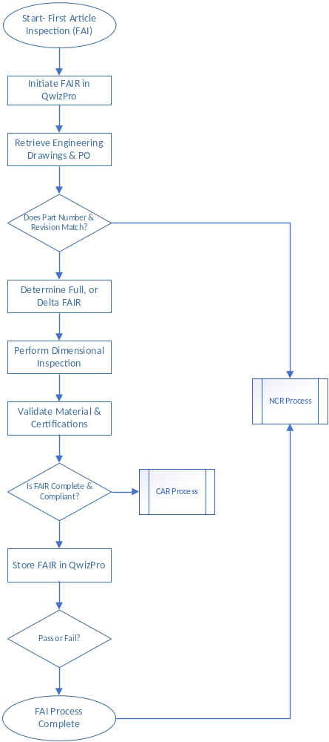
First-time production FAIRs are reviewed with Engineering and Quality to confirm requirements were met.
Prototype Inspection
- Prototype inspections are performed on first-time builds, engineering test articles, or non-production units to verify design intent and manufacturability.
- Conducted in coordination with Engineering, Quality, and Manufacturing at SPR and MXL production sites.
- Inspection results are recorded in QwizPro and stored per AS9102 documentation requirements.

Prototype Inspection Steps
- Initiate Prototype Inspection  - Verify that the prototype part is classified correctly (Engineering prototype, First Article, or Special Test Article).  - Retrieve the latest engineering drawings, specifications, and purchase order requirements.  - Open a First Article Inspection Report (FAIR) record in QwizPro (if applicable).  - Perform Dimensional Verification  - Use calibrated measuring tools per Control of Monitoring and Measuring Equipment procedures.  - Measure all critical dimensions and verify tolerances against the engineering drawing.  - Record results in AS9102 Form 3 in QwizPro.  - Material and Process Validation  - Confirm that materials used align with the engineering bill of materials.  - Verify all material certifications, process validations, and special process approvals.  - Document findings in AS9102 Form 1.  - Engineering and Quality Review  - Engineering and Quality jointly review the FAIR results.  - If any deviations or nonconformances are identified, initiate an NCR and escalate per procedure.  - If corrective actions are required, Engineering determines the modifications needed for production readiness.  - Approval and Storage of FAIR Documentation  - Upon successful validation, the FAIR is approved and stored in QwizPro.  - Prototype parts are either cleared for further testing, design iteration, or production release. | 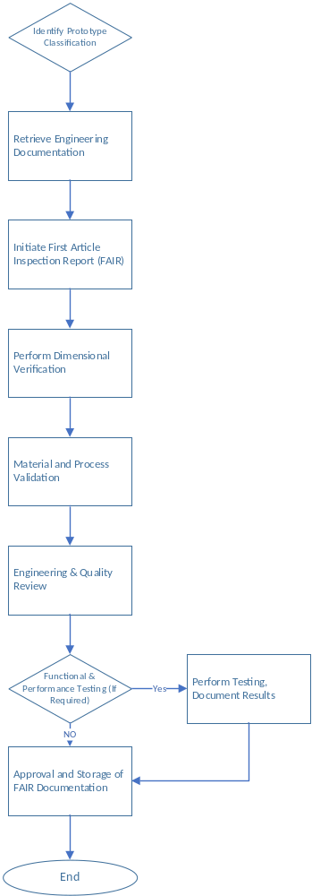

In-Process Inspections
- In-process inspections occur at all production locations, including MXL Operations and SPR.
- Inspections are performed at designated intervals within the production process to verify compliance with engineering specifications, regulatory requirements, and quality standards.
- The job traveler should include designated in-process inspection points. If an inspection point is missing, the inspector must document when in the process the inspection occurred, and email the production engineer to add the process step. CC Quality Control Manager.
If there is no job traveler, the inspector must document the inspection results in Epicor under the job notes section for full traceability and report to the production engineer for addition to the system, CC the Quality Manager.
In-Process Inspection Steps:
- Verify Job Traveler and Inspection Requirements  - Review the job traveler and ensure inspection intervals are defined.  - Identify key characteristics, critical features, and regulatory requirements.  - If an inspection step is missing, the inspector must document when the inspection occurs.  - If a job traveler is not available, the inspector logs the inspection details in Epicor job notes.  - Conduct Dimensional and Visual Inspection  - Use calibrated measuring tools per Control of Monitoring and Measuring Equipment procedures.  - Inspect and measure critical features as defined in engineering drawings.  - Record results in QwizPro, ensuring traceability to job number, lot, or serial number.  - If a job traveler is not used, record measurements and inspection results in Epicor job notes.  - Material and Process Verification  - Confirm that materials used align with engineering and purchase order requirements.  - Validate that any special processes (plating, heat treatment, etc.) have been completed and documented.  - If applicable, review material certifications and processing records.  - Functional and Performance Testing (If Required)  - Conduct required functional tests as defined in engineering and process documents.  - Verify that test results meet acceptance criteria and document findings.  - Any out-of-tolerance conditions must be escalated per the Nonconforming Material process.  - Traceability and Documentation  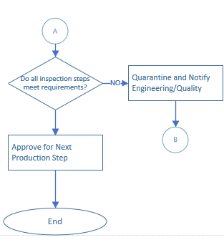  - Ensure in-process inspection records are linked to the Epicor job number and QwizPro.  - Attach all relevant inspection checklists, test reports, and material certifications as needed.  - If a job traveler is not used, document all findings and traceability details in Epicor job notes.  - If nonconformances are found, initiate an NCR and escalate per established procedures.  - Approval and Process Continuation  - If all characteristics meet acceptance criteria, approve the article for the next production step.  - If deviations are found, quarantine the part and notify Engineering/Quality.  - Maintain a detailed log of inspections for regulatory and customer review. | 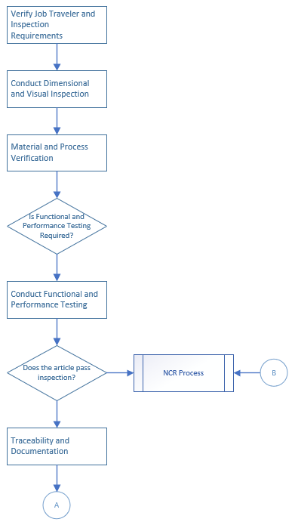
Final Inspection
- Final inspection occurs at the end of production before the conformity inspection and issuance of 8130-3.
- This inspection is performed to ensure that the article meets all engineering, manufacturing, and quality requirements before moving to the final conformity assessment.
- Conducted at MXL Operations and SPR locations for all completed production articles.
- When possible Results are recorded in QwizPro and attached to the corresponding job in Epicor, but must be recorded.

Final Inspection Steps:
- Review Job Traveler and Engineering Documents  - Verify that all required production steps are completed before final inspection.  - Ensure the article meets engineering drawings, work instructions, and process requirements.  - Confirm all required process validations and sign-offs are completed before inspection.  - Perform Dimensional and Visual Inspection  - Use calibrated measuring tools in accordance with Control of Monitoring and Measuring Equipment procedures.  - Verify all critical and key characteristics per engineering drawings and inspection plans.  - Confirm the part is free from defects, damage, or cosmetic nonconformities.  - Material and Special Process Validation  - Validate that the correct materials were used per engineering specifications and purchase orders.  - Ensure any special processes (plating, heat treating, conformal coating, etc.) are certified and documented.  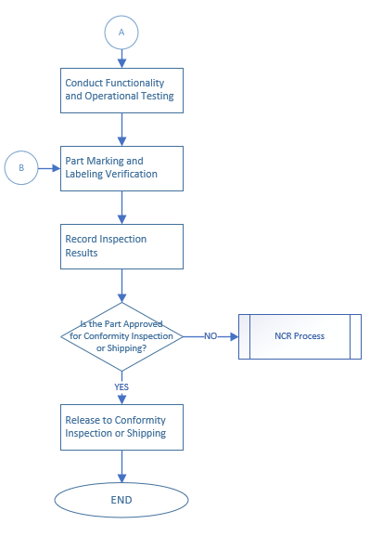  - Confirm material traceability and batch records are complete and accurate.  - Functionality and Operational Testing (If Required)  - Conduct final functional tests per work instructions and test plans.  - Document results and confirm compliance with customer and regulatory requirements.  - Any failures or deviations are escalated per Nonconformance Handling Process (NCR).  - Part Marking and Labeling Verification  - Verify part marking accuracy against engineering drawings and regulatory standards.  - Ensure labels are legible, correctly formatted, and securely affixed.  - Confirm all required traceability information is included.  - Record Inspection Results  - Log inspection findings, approvals, and any required corrective actions in QwizPro.  - Ensure all supporting inspection records, material certifications, and test results are attached to Epicor.  - Any nonconforming parts are documented with an NCR and quarantined per procedure.  - Release to Conformity Inspection or Shipping  - If all criteria are met, approve the article for:  - Conformity Inspection (if 8130-3 is required).  - Packaging and Shipping (if a CoC is sufficient for release).  - If the part fails inspection, follow the Nonconformance Handling Process. | 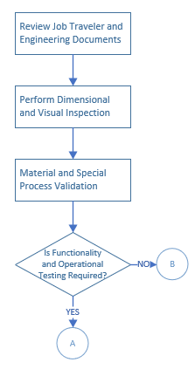

Production PMA Inspection Process (8130-3): See Attachments for Sample Documents
- Review the PMA Supplement Approval  - Verify that the PMA Supplement aligns with documented engineering specifications and regulatory requirements.  - Cross-check against the FAA-approved PMA listings to confirm the part is properly authorized for PMA issuance.  - Validate revision levels and approval dates for compliance with FAA records.  - Verify Traceability Documentation  - Ensure all required traceability records (e.g., lot numbers, serial numbers) are attached and match the incoming shipment details.  - Cross-check PMA part markings against the approved engineering drawing and design records.  - Inspect for Compliance with 14 CFR 45.15  - Confirm that the part markings comply with FAA regulations, ensuring:  - Presence of correct PMA identification.  - Proper label placement and legibility per FAA Order 8130.21.  - No inconsistencies in serial numbers or batch information.  - Validate the labelling against engineering drawings and ensure durability of markings.  - Confirm that material and process certifications match the PMA approval requirements.  - Confirm Required Documentation  - Review and verify that all necessary documents are complete, including:  - PMA Supplement reference (linked to approved design data).  - FAA Form 8100-1 inspection record, ensuring all key characteristics are recorded.  - Material certifications as applicable.  - Any supporting engineering documentation for prototype or first-run inspections.  - Attach all required documentation to Epicor and QwizPro.  - Determine Required Certification Type  - Identify whether the part requires an 8130-3 or Certificate of Conformance (CoC) based on:  - Customer requirements (contract/order details).  - Regulatory compliance (FAA-mandated conformity verification).  - If an 8130-3 is required, verify the supplement number and approval status before issuing certification.  - If issuing CoC, confirm that all required traceability and conformity documentation is properly attached.  - Bulk Tagging Consideration  - If the part meets bulk tagging criteria, refer to 8130-3 Split Tags section and follow the proper issuance steps.  - Confirm that all required documentation is uploaded to Epicor and QwizPro.  - Remote Conformity or Virtual Inspection (VI) Process  - If an 8130-3 inspection must be performed remotely, follow the Burrana FAA-approved Remote Conformity Process.  - The inspector will coordinate with the receiving location and confirm that the supplier is eligible for remote conformity inspection.  - Live video and audio feeds must be used for the inspection, ensuring that all required characteristics are properly reviewed.  - The inspector must review:  - All documentation, certifications, and traceability records in real time.  - Part marking and label compliance per 14 CFR 45.15.  - Dimensional and visual characteristics as applicable to the part’s approval.  - Use FAA Form 8100-1 as the official inspection record.  - If the remote conformity process fails to verify compliance, determine the next step:  - Conduct a secondary remote inspection.  - Ship the product to an authorized Burrana location for in-person inspection.  - Send a qualified inspector to the supplier site for in-person verification.  - All inspection records, results, and documentation must be recorded in QwizPro, with links to the Epicor lot or job.  - Inspection Location Determination  - MXL: Only CoC inspections are performed in MXL unless remote conformity is scheduled.  - Springville (UT) or Calexico (CLX): These locations perform full PMA inspections and 8130-3 issuance.  - Remote Inspections: If remote conformity is required, confirm eligibility and use Burrana’s approved Remote Conformity Process.  - If an article arrives at MXL requiring an 8130-3, it must be:  - Transferred to Springville or Calexico for a physical PMA inspection.  - Approved for remote conformity inspection.  - Rejected and dispositioned per the NCR process if nonconforming.  - Record Inspection & Approvals  - Document all inspection findings, approvals, and PMA conformity verification in QwizPro.  - Attach the FAA Form 8100-1 to the Epicor job or lot record for traceability.  - Ensure all bulk inspection records and traceability documentation are stored per Burrana’s document control requirements.  - Nonconformance Handling  - If any discrepancies are identified, follow the Nonconformance Handling (NCR Process) to determine disposition (Rework, Scrap, Return to Supplier, etc.).  - If supplier-related, issue a Supplier Corrective Action Request (SCAR) and notify Purchasing for resolution.  - All NCRs must be recorded in QwizPro and linked to Epicor for traceability. | 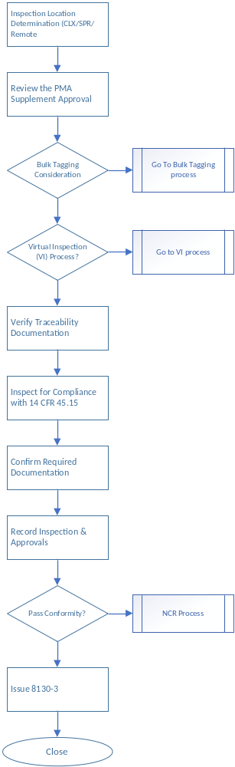
Issuance of Bulk 8130-3
- Verify that all articles to be included in the bulk shipment meet quality and regulatory requirements.
- Confirm that Burrana has PMA authority for all articles in the shipment.
- Complete FAA Form 8130-3 using the standard template.
  - Ensure Blocks 1-11 are correctly filled out with article details.
  - In Block 12, include the required certification statement.
- Obtain required approvals and signatures from authorized personnel.
- Attach the completed FAA Form 8130-3 to the bulk shipment.
- Log the issued 8130-3 in Epicor to the lots and maintain the hard copy on file at the site until the lot is depleted, with digital copies retained per regulatory and customer requirements for tracking and compliance.

Pre-Splitting Validation
- Verify the original FAA Form 8130-3 is valid and correctly signed.  - Ensure Burrana is authorized to issue 8130-3 for split shipments.  - Inspect the shipment for damage, discrepancies, or nonconformances.  - Confirm traceability requirements are met. | 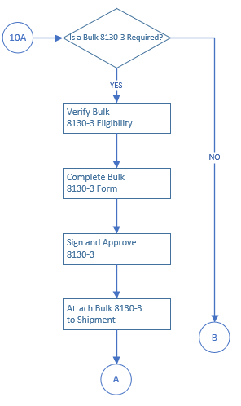

Splitting the Bulk Shipment
- Physically separate the parts/articles as per split requirements.
- Generate a copy of the original FAA Form 8130-3.
- Use the 8130-3ST template to create a new 8130-3 for each split subset.
- Complete Blocks 1-11 as per the original form.
- In Block 12, verify and update the statement with the correct information:
  - “This is a split shipment. The original shipment was accompanied by FAA Form 8130-3 #[original form number], dated [original date].”

Ensure all documentation is accurate and complete.

Packaging and Labelling
- Ensure each subset is packaged securely and labeled correctly.
- Attach the corresponding 8130-3ST to each subset.
- Apply appropriate shipping labels with:
  - Part Number (P/N)
  - Serial Number (S/N) if applicable
  - Reference to the original shipment PO

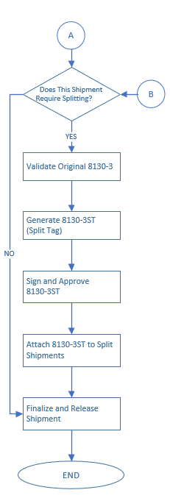
Documentation and Recordkeeping
- Log the new 8130-3ST numbers into Epicor to the lots and maintain the hard copy on file at the site.
- Maintain records of all split shipment forms for at least two years.
- Conduct a Quality Inspection before release.
Virtual Inspection (VI) Process
Virtual inspections are performed when an in-person inspection is not feasible due to logistical constraints, remote locations, or efficiency considerations. This process ensures that all inspections comply with FAA and regulatory standards while maintaining full traceability and documentation.
These may take place only at approved locations and with the appropriately qualified inspectors.

1. Initiate Virtual Inspection (VI) Request  - Determine whether the part qualifies for remote conformity inspection based on regulatory and customer requirements.  - Verify that the supplier or receiving facility is eligible for remote inspection.  - Schedule the VI session and coordinate with the onsite personnel to ensure proper setup.  - Assign an authorized inspector to conduct the virtual inspection.  2. Prepare for Inspection  - Confirm that the necessary documentation is available and ready for review, including:  - Purchase Orders (PO)  - Certificates of Conformance (CoC)  - FAA Form 8130-3 (if applicable)  - Material certifications  - Engineering drawings and specifications  - Ensure that live video and audio equipment is set up at the inspection location.  3. Conduct Virtual Inspection  - The inspector directs the onsite personnel to present the part in real-time via live video.  - Verify the part marking and labeling in compliance with FAA Order 8130.21 and 14 CFR 45.15.  - Review the physical condition of the part, checking for any signs of damage or discrepancies.  - Dimensional verification may be conducted if necessary, with the onsite personnel measuring critical dimensions under the inspector’s direction.  - Ensure that the traceability documentation aligns with the shipment details.  4. Verify Inspection Compliance  - Review part marking placement, legibility, and correctness against engineering drawings and regulatory standards.  - Confirm that the PMA Supplement Approval and associated FAA records align with Burrana’s approved design data.  - If the part requires an 8130-3, confirm that the supplement number and approval status are validated before certification.  5. Document the Inspection Results  - Use FAA Form 8100-1 as the official inspection record for virtual inspections.  - Attach all inspection findings, certifications, and traceability documents to Epicor and QwizPro.  - If the part meets all compliance requirements, approve the inspection and move forward with certification.  6. Nonconformance Handling  - If any discrepancies are identified during the virtual inspection, initiate an NCR (Nonconformance Report).  - If remote verification fails, determine the next course of action:  - Conduct a secondary virtual inspection.  - Ship the part to a Burrana-approved location for an in-person inspection.  - Arrange for an onsite inspector visit to the supplier facility.  - All nonconformances and SCAR (Supplier Corrective Action Requests) must be documented in QwizPro and linked to Epicor. | 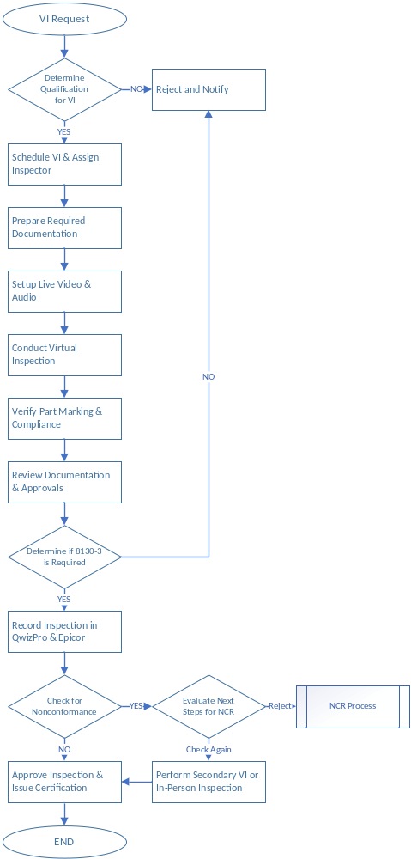
Service Center MRO/SPR Inspection Process
- Springville, UT (SPR) and Mexicali (MXL) Repair Centers are FAA Part 145 approved repair stations.
- MXL Repair Center Approvals: FAA Part 145, CAAC, AFAC, EASA.
- Springville (SPR) Approvals: FAA Part 145, UK CAA, EASA, CAAC.
- Repair capability is based on the CAPA list maintained by each facility. If an article is not listed on the MXL CAPA, it may still be on SPR’s CAPA and vice versa.
- Remote inspections (VI) are conducted between MXL and SPR for articles that require additional regulatory approvals.
- Where MXL does not hold an approval, articles are either inspected remotely or transferred to SPR for inspection.
Service Center MRO/SPR Inspection Steps:
- Confirm Repair Eligibility
  - Verify that the article is on the approved CAPA list for repair at the receiving facility.
  - If the article is not on the receiving facility’s CAPA list, check if the other facility (SPR or MXL) has approval.
  - If the article is not approved at MXL, determine if:
    - The article qualifies for remote inspection (VI process).
    - The article must be shipped to SPR for inspection and certification.
  - Confirm customer requirements for documentation (CoC or 8130-3 issuance).
  - Identify whether the repair is for domestic or export, ensuring proper regulatory compliance.
- Inspection and Testing Process
  - Conduct a receiving inspection to validate part condition.
  - Ensure repair procedures follow the approved repair station manual.
  - Verify that all necessary inspections, functional tests, and verifications are performed per regulatory requirements.
  - Confirm material traceability and repair documentation are attached to the work order.
  - If additional inspections are required per CAAC, EASA, or AFAC, escalate the review to SPR.
- Final Inspection and FAA Form 8130-3 Issuance
  - Confirm all repair actions meet FAA, EASA, CAAC, or AFAC conformity requirements.
  - Review all traceability documentation, material certifications, and work records.
  - Verify the final test results for functional conformance.
  - Determine whether the part is for domestic or export and document this in Block 12 of FAA Form 8130-3.
  - If MXL lacks approval for a required regulatory certification, the article must be:
    - Transferred to SPR for final inspection or,
    - Inspected remotely using the Virtual Inspection (VI) process.
- Remote Conformity Process
  - If an article cannot be inspected on-site, use remote inspection procedures.
  - Ensure live video and audio feeds are used to validate:
    - Repair documentation and regulatory approvals.
    - Functional tests and final inspections.
    - Part markings and label compliance per FAA Order 8130.21.
  - The inspector must document findings in QwizPro and attach all supporting records to Epicor.
  - If remote inspection fails to verify compliance, the article must be shipped to SPR for final inspection.
- Final Documentation and Record Retention
  - Upload all 8130-3 forms, work records, and inspection results into Epicor.
  - Maintain compliance records per FAA, EASA, CAAC, AFAC, and Burrana retention policies.
  - Ensure full traceability of all repair inspections and approvals for regulatory audits.

Service Center MRO/MRC Inspections:
MRC Service Center has 4 inspections:
Preliminary Inspection.

This inspection is an evaluation of an article to determine the customer-requested work scope and the required maintenance or alteration actions, assurance the follow information:

Hidden Damage Inspection.

The disassembled components will be thoroughly inspected by an inspector, a technician lead could support the inspection as require, for hidden damage or defects in adjacent areas. This may be performed following an initial cleaning as deemed necessary.
Hidden damage will be reported to the customer by the Customer Service Representative as required.

In-Process Inspections.

Detail inspections will be in accordance with Maintenance Task Card instructions, as required.

Final Inspection/Return to Service.

FAA form 8130-3 is to be used for release to Service of any article. Release to service approved Certifying Staff will perform the final inspection and the record package completed by a technician, to determine that all work has been performed in accordance with the approved technical data and that each discrepancy has a corresponding corrective action recorded.
Preliminary Inspection Steps:
Review proper documentation, identification, and traceability of the unit and materials  Review compliance with AD and service bulletins required by customer.  Make the functional test and filling out the Repair station teardown report.  Confirm if FAA approval for the units and components.  Determination of what kind of repair is necessary. |  | 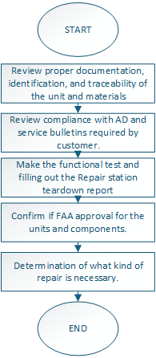
Hidden Damage Inspection Steps:
Review if the articles have been involved in an accident, is so will be thoroughly inspected for hidden damages in all areas.  Any findings discovered during hidden damage inspection will be recorded on the Repair Station Tear Down Report. The part will be routed to the quarantine area for storage pending customer disposition instructions.  May be searched for secondary hidden damage support as necessary from the technical support engineering and this inspection will include, but will not be limited to, areas adjacent to the obviously damaged assemblies or components.  Report any Findings during hidden damage inspection on those products that have been involved in an accident to the Quality Manager. |  | 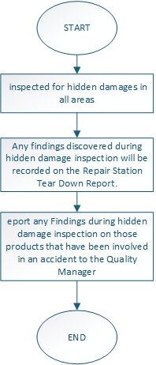
In-Process Inspections Steps:
Perform detailed inspections according to Maintenance Task Card instructions  Detail inspections are performed during the overhaul/repair of the component, testing and calibrations of tooling used.  Any defects or damage found will be recorded on the Repair Station Tear Down Report, LOG DEFECTS and Maintenance Task Card as applicable. Entries will be accompanied by the one making the entry and the date the entry was made. |  | 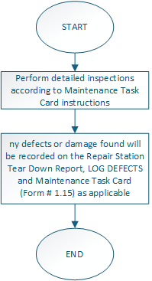
Final Inspection Steps:
Inspection and Testing Process. Final inspection is performed using the Units Verification Checklist, section 5. FINAL INSPECTION, the following items are validated:  Wrist ESD verification completed.  Bench ESD verification and record on checklist F-854-15.  Training Matrix is update.  All maintenance and company procedures applicable are complete.  Related component is in the approved EASA, FAA Part 145 or CAAC capability list as required.  CS is qualified for this equipment in OJT file.  The Nameplate SN & PN matches with PO and system.  ESD Protection and Pins Connectors are OK.  Visual inspection of the component making sure there is no damage and Mechanical functions are satisfactory.  Loose or missing hardware.  Customer needs/requests and instructions in the PO were met.  Connector keying conforms to unit status (if applicable).  Failed parts reflected.  Correct technical data was used to perform the maintenance tasks and used for testing. Correct approved data was used.  Correct Software used and reflected in task card (if applicable).  Test and product repair. It should be all acceptable  Tamper proof Seals (if applicable).  Complied with all applicable Airworthiness Directives.  Outgoing unit mod status agrees with paperwork.  In process and finals inspection data. It should be all acceptable  Requested level of work is completed.  JOB/TDR properly completed.  Correct parts and material certificates are available. Proper certificates of all parts replaced during the repair.  Customer documents and documents requested by customer.  (8130/Form 1, CAAC Tag, Teardown and Task card)  Component is pre-packed properly.  NOTE: If any discrepancy is found in any of the above items, the final inspection will be stopped and returned to the applicable technician notifying the discrepancy found, the discrepancy will be recorded on the LOG DEFECTS  Final Inspection and Release to service Issuance  Release to service approved Certifying Staff will perform the final inspection and the record package completed by a technician, to determine that all work has been performed in accordance with the approved technical data and that each discrepancy has a corresponding corrective action recorded.  All entries must be legible, and initials and/or stamps must clearly identify the ones making entries.  Only Certifying Staff specifically identified by the Repair Station Roster may perform final inspection or return a part to service.  The Inspector will sign or stamp and date the Repair Station Tear Down Report and release to service certificate of articles indicating that successfully pass the final inspection.  The original signed release to service certificate and Repair Station Tear Down Report attached to the article identifies it as a serviceable part.  Final Documentation and Record Retention  3.1 Upload all Release to service Certificate, work records and inspection results into Epicor.  3.2 Maintain compliance records per FAA, EASA, CAAC, AFAC, and Burrana retention policies.  3.3 Ensure full traceability of all repair inspections and approvals for regulatory audits |  | 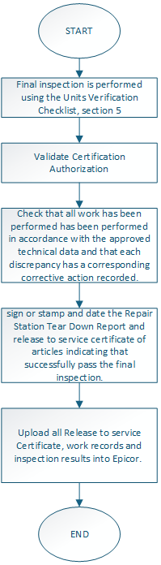

Governing Standards
- AS9100
- AS9110
- FAA 14 CFR Part 21
- FAA 14 CFR Part 145

Related Processes
- P-851-02 PMA Inspection
- P-851-05 Remote Inspection and Test Witnessing
- F-851-07 Remote Inspection Authorized Locations and Personnel
- SOP-852-10 Split Tags

Training
The Inspections SOP applies to multiple roles within Burrana, ensuring compliance with regulatory, quality, and customer requirements. The following personnel require training:
- Quality Control Inspectors (QCI) – All Locations
  - Responsible for performing all inspections outlined in the SOP.
  - Must be trained on receiving inspection, in-process inspection, final inspection, PMA inspections, and MRO/Repair station inspections.
  - Includes training on the use of Epicor and QwizPro for inspection record-keeping.
- Manufacturing Technicians & Production Operators
  - Trained on in-process inspections to verify critical characteristics before moving parts to the next production step.
  - Understand when to escalate nonconformances for engineering review or quality control intervention.
  - Learn proper documentation of inspections in job travelers or Epicor.
- Receiving Inspection Personnel
  - Required for warehouse personnel and designated receiving inspectors at all Burrana locations (MXL, SPR, CLX).
  - Training covers proper handling of incoming materials, verification of supplier documents, and traceability requirements.
- Quality Engineers (QE) and Customer Quality Engineers (CQE)
  - Must be familiar with inspection requirements and regulatory compliance to support audits and customer inquiries.
  - Understand nonconformance processes, corrective actions (SCARs/NCRs), and regulatory requirements (FAA, EASA, CAAC, AFAC).
- Repair Station Personnel (MRO – SPR & MXL)
  - Required for repair station inspectors and technicians who handle FAA 8130-3 issuance.
  - Training includes inspection for returned and repaired parts, traceability verification, and regulatory compliance.
  - Covers Remote Conformity Process (VI Inspections) for parts requiring virtual inspection before return to service.

- Purchasing & Supply Chain Personnel
  - Training focuses on reviewing supplier documentation (CoC, material certs, 8130-3, EASA Form 1) before acceptance.
  - Understands escalation procedures for nonconforming shipments.
- Engineering (Design & Manufacturing Engineers)
  - Trained on FAIR (First Article Inspection) and prototype inspections.
  - Learn how to define inspection requirements in job travelers and work instructions.
  - Collaborate with Quality Control for corrective actions and process improvements.
- Regulatory & Compliance Personnel
  - Ensures that Burrana remains in compliance with FAA, EASA, CAAC, AFAC regulations.
  - Trained on inspection documentation, audit preparation, and traceability requirements.

Attachments

Sample 8130-3  This is the top level 8130-3 used for scheduled inspections or Bulk Inspections. | 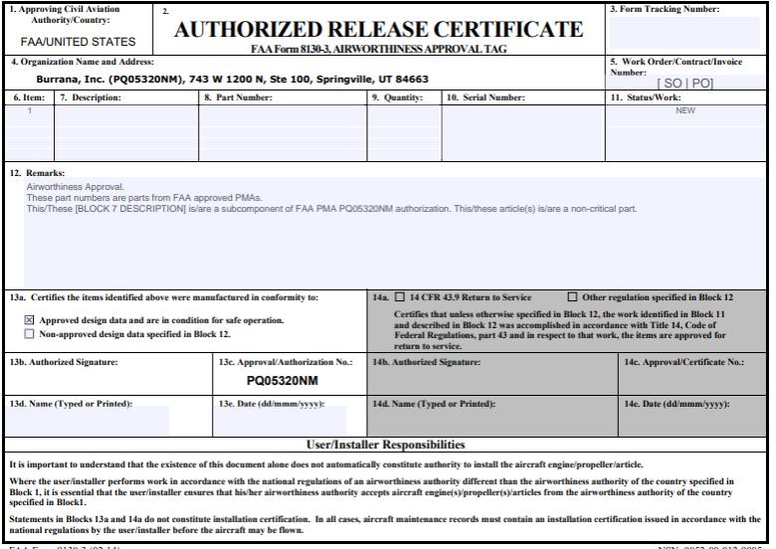
Sample Export 8130-3ST  The Inspector must complete block 12 | 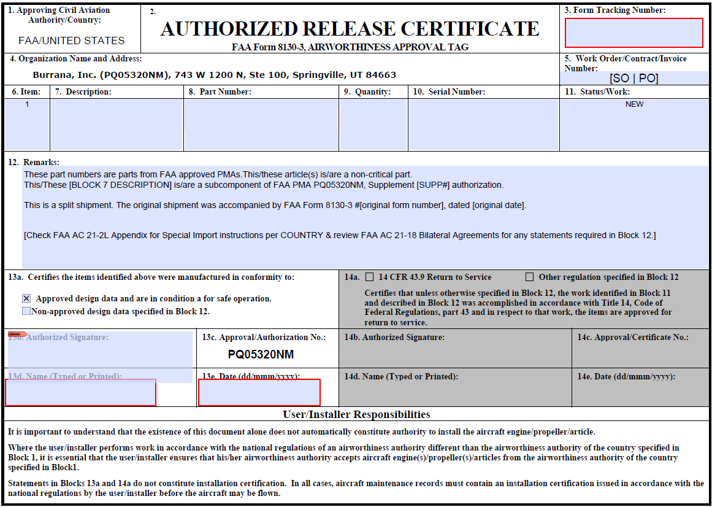
Sample 8130-3ST Domestic  The Inspector must complete block 12 | 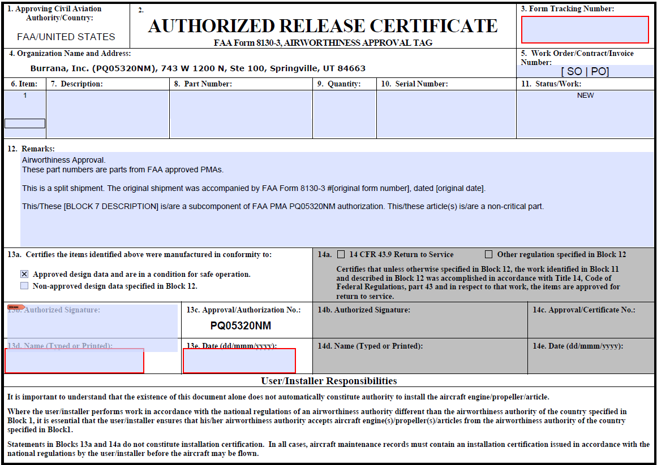
Sample 8100-1 form | 